Links: <https://concordia.udemy.com/course/azure-devops-for-project-managers-analyst/learn/lecture/36955438#overview>

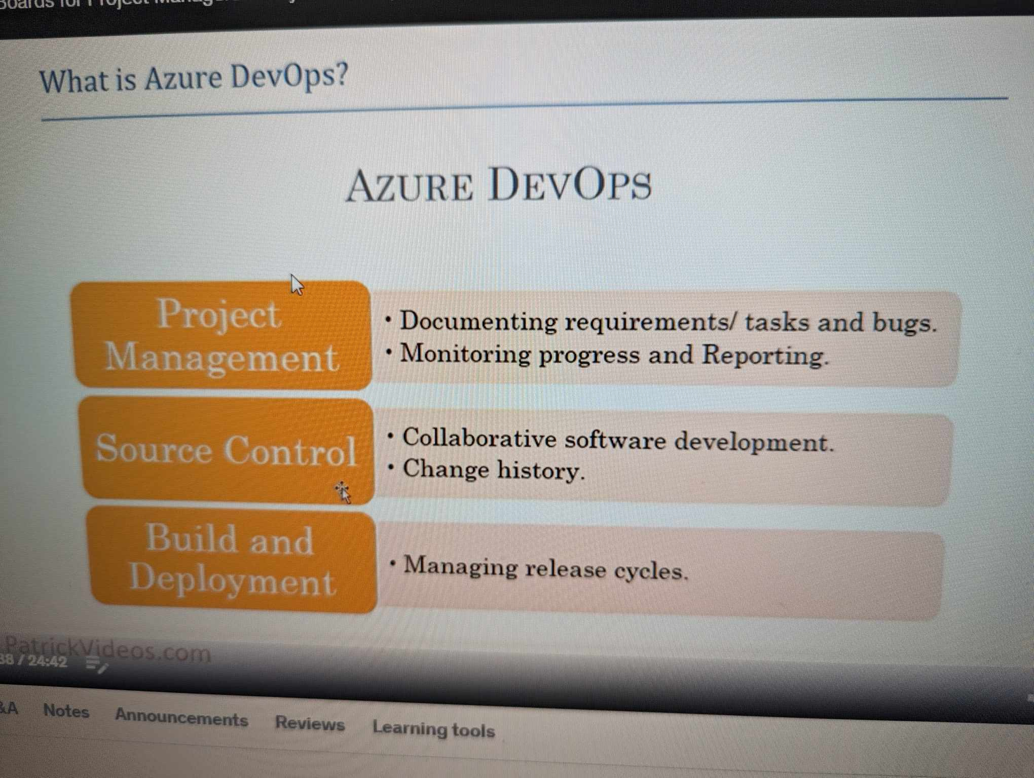

Create a project with scrum (advance options) and another one with default option.

Go to scrum –profile—enable all the option

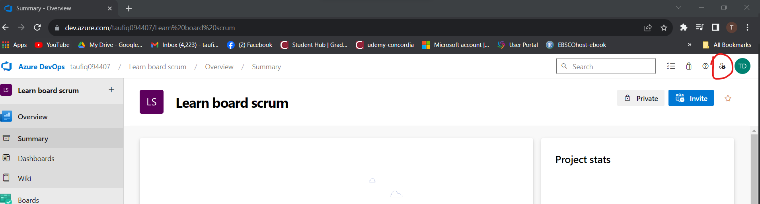

Adding members:

Click on invite then add members.

Or go to project setting (bottom left)—teams—choose your project and see/add members.

Also I can create new teams in team tab ( for ex: stakeholders) and I can assign them roles ( readers, contributors,admins etc)

Security: who has what roles:

Go to –permission and in contributer and admins add those user ( in admins added users will be administrators and in contributor they will be contributor—simple)

**Setting up sprints in azure**

Once team and permission is done, time to focus on scrum lifecycle:

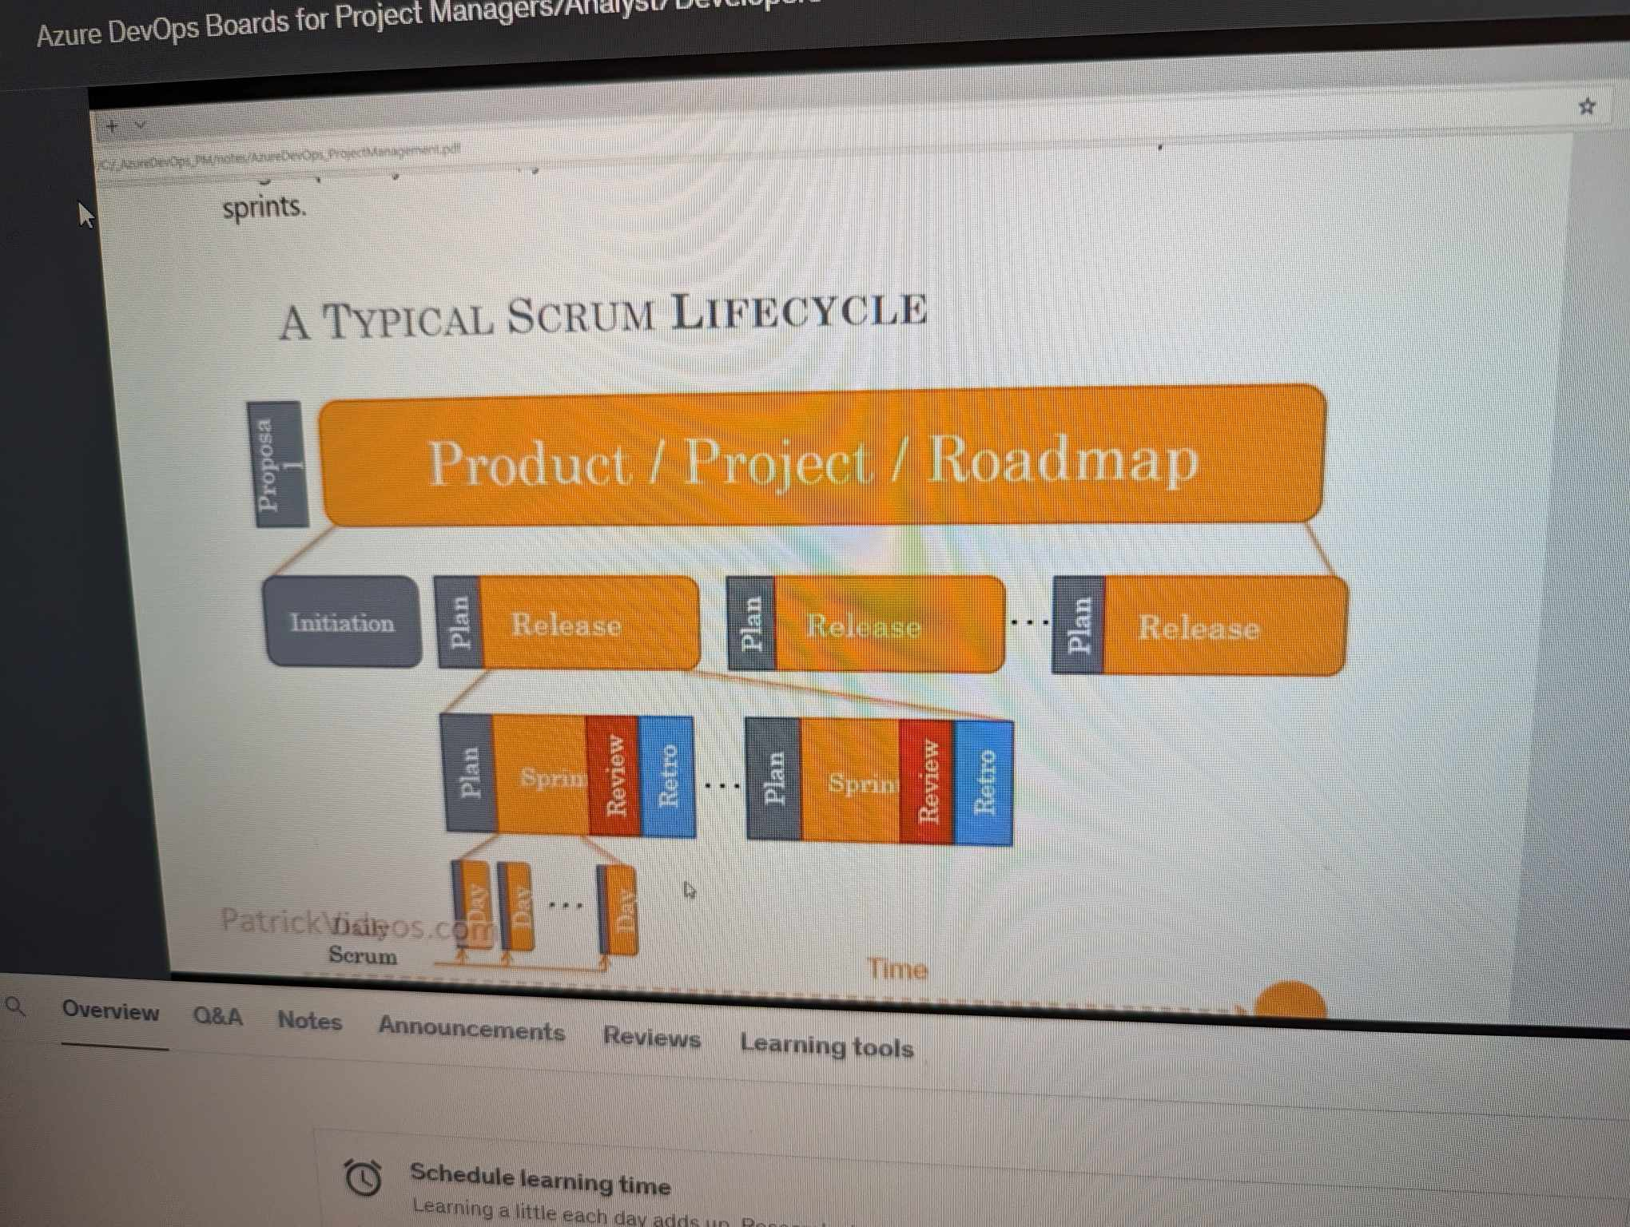

Project setting—project configuration-

But its not enough to have them configured only in project configuration. You also need them in team configuration.

Go to –team configuration—check features—iterations—select sprints that you created. ( its also must)

Now area is an important factor. Say multiple teams are working on same project so we need to create multiple areas( its like containers) so that one team does not see the requirements of another team.

Create epic, user stories etc:

**Epic—features—user stories---task**

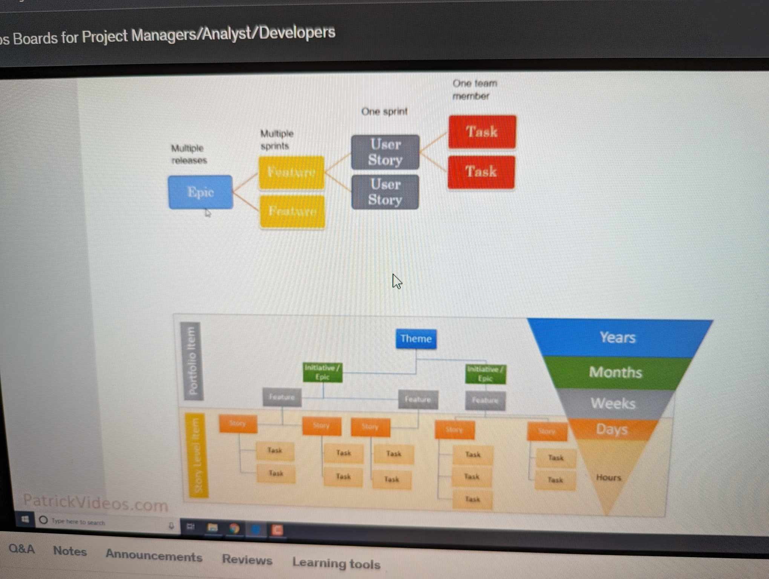

Creating features:

Go to –backlogs—right isde-choose epic—middle + sign and create features

Note: if you don’t see new features then either you are reader/stakeholder ( you must be contributor/admins)

Creating user stories:

Go to backlogs—expand features – product backlog features(may be renamed as user story in company rules already)

If I want to add more column apart from default one like state,efforts (shown above), I can use column options to add. (very easy)

Create task:

Click on + on product backlog items.—new task—

If I am not mentioned in a task but want to follow it then:

Open any task, user story etc and click on ‘follow’.

Template:

Used for automation. For exm: I have a task called daily meeting. So in every user story I will have meeting. So I can create a task called ‘daily meeting’ .just save it and top right … click on template and save it. Then I can use that template in other taks/user stories. Very useful.

Another similar one is copy task under … as well.

1. Link to existing click meaning under same parent (links)—say I already have 2 task now I will have 3
2. Uncheck means I will choose the parent link for that. –this will be new task under new parent copied form existing task.
3. A screenshot of a computer

   Description automatically generated

Also you can email the work item from … to managers and colleagues etc.

Working with sprints:

Go to sprint—

Taskboard—tasks are shown here,you can move task (to do..done) or you can create customzed task like column options.

Also you go to backlogs and see the tasks and user stories etc.

Capacity planning:

In the sprint there is option called ‘capacity’ planning (see ss below).

1. In capacity planning say Taufiq can work on development for 5 hours and qa for 3 hours.
2. In backlog go to _-- (beside setting) –work details – to see if that person has enough capacity hours to do the work. For ex: work is 8 hours but he has 5 hours so it will be red.
3. A screenshot of a computer

   Description automatically generated

Queries:

Go to work items—filter by name, tags etc.

Or we can use ‘Query’ part.

create epic in tree structure:

Also you can save a custom query—go to chart—create charts

Also we can send this query in email … .say manager wants to see which query I am working on.

Dashboards:

Go to overview—dashboard—

You can choose widgets like assigned ot me , query result and much more here.

Import from azure devops to excel:

Excel-team tab—new list—give upto project name ( <https://dev.azure.com/taufiq094407> )

So in excel you can connect to queries that you saved and also make changes to excel file and puslish it to azure and aure will change accordingly.

Notification settings:

See ss below. You can on or off notifications here.

Also I can choose multiple tasks and eidt them together. Like making status as ‘done’ for both at a time.

Create custom process:

Azure devops—organizational setting—process—scrum—create inherited process

Give process name—like Taufiq process. Create a new work item. For example: ticket

Go to azure devops—create new project—in the ss below you will see along with scrum, Basic we have our custom process.

Now you will see—in that new project—work item—in new work item we have ticket that we created as workitem under Taufiq process.

Now if I want template to be different then default template (for ex: ticket default template I need my customized template)

So go to Taufiq process—ticket and new page.

Now go to azure-devops—custom project(Taufiq process selected while creating this project)-Board-work items—new work item—ticket—now at right upper side you will see both Details and ticket page( I created that above ss) that has All the information that I customized. ( acceptance criteria, accepted date etc)

Creating some rules:

Adding values to custom fields we created above.

Organization setting-process-taufiq process-Ticket—Rules tab

Now when I go to –work item-ticket – I see –‘value dao nai’’ in the box automatically

